Table of Contents:

Introduction
Tetris is a legendary puzzle video game created in 1984 by Russian software engineer Alexey Pajitnov while working at the Soviet Academy of Sciences. What began as a simple experiment in geometric arrangement quickly became a global phenomenon and remains one of the most influential games in video game history.
This project focuses on designing and implementing an artificial intelligence (AI) system capable of playing Tetris autonomously. Although Tetris appears simple, it demands sophisticated spatial reasoning, optimisation, and real-time decision-making. From a computational standpoint, it represents a challenging optimisation problem: the AI must select the best move from a large action space while dealing with uncertainty about future pieces.
Building an AI for Tetris provides an opportunity to explore advanced computational intelligence techniques such as neural networks, heuristic evaluation, evolutionary algorithms, and simulation-based decision-making. This chapter outlines the theoretical background behind a genetic neural network, an approach that evolves a neural network’s weights using evolutionary computation rather than traditional gradient descent.
From a computational perspective, Tetris is particularly challenging because it combines a vast state space with incomplete information. The player (or AI agent) has no knowledge of future tetrominoes beyond the next piece, and each decision permanently alters the board. This makes Tetris unsuitable for brute-force search or exact optimisation methods.
As a result, most successful artificial intelligence approaches rely on heuristic evaluation or learned models rather than exact solutions. This project adopts that philosophy by using a neural network as an evaluation function, with its parameters optimised using a genetic algorithm rather than traditional supervised learning.

Core Gameplay Overview
Objective:
Players rotate and position falling geometric shapes (tetrominoes) to complete horizontal lines. Completed lines disappear, awarding points and clearing space. If blocks stack to the top of the grid, the game ends.
Mechanics:
- Tetrominoes: Seven unique shapes (I, O, T, L, J, S, Z), each composed of four squares.
- Controls: Rotate, move left/right, or drop pieces before they lock.
- Difficulty: Piece fall speed increases as levels progress.
Key Features:
- Universal accessibility and intuitive mechanics
- Scoring based on line clears (four lines at once = “Tetris”)
- Endless play with competitive high-score potential

Cultural and Historical Impact
- Cold War Origins: Spread via floppy disks from the USSR to Western markets.
- Legal Significance: Complicated rights disputes made it a notable case in intellectual property law.
- Platform Reach: Available on virtually every major system, from Game Boy to modern smartphones.
- Scientific Interest: Used in research on cognitive performance and PTSD therapy.
Legacy:
- Competitive tournaments such as the Classic Tetris World Championship
- Educational use in teaching spatial reasoning and problem-solving
- Frequent appearances in films, music, and art

Requirements and Objectives

1.1 Core Gameplay System
The program must implement a fully functional version of the game Tetris.:
1.1.1 Creating a 10×20 game grid using a two-dimensional array.
1.1.2 Implementing all seven standard tetromino shapes.
1.1.3 Allowing tetrominoes to fall, move left and right, and rotate.
1.1.4 Detecting collisions with the grid boundaries and existing blocks.
1.1.5 Locking tetrominoes in place when they land.
1.1.6 Detecting and clearing completed lines.

1.2 Visual Game Board and Rendering
The system must visually represent the game state clearly to the player.
1.2.1 Rendering the game grid using Pygame.
1.2.2 Displaying coloured blocks for each tetromino using sprite images.
1.2.3 Drawing grid lines to clearly separate cells.
1.2.4 Updating block positions smoothly using a sprite group system.
1.2.5 Displaying a “next tetromino” preview.

1.3 Menu and Navigation System
The system must provide a menu interface to allow the user to navigate between game modes.
1.3.1 Implementing a main menu with buttons for:
.2 Human play
.3 AI play
.4 AI vs Human mode
.5 Options
.6 Quit
1.3.2 Allowing mouse interaction with buttons.
1.3.3 Loading the appropriate game mode based on the user’s selection.

1.4 Scoring System
The system must track and display the player’s score.
1.4.1 Awarding points based on the number of lines cleared at once.
1.4.2 Updating the score in real time.
1.4.3 Displaying the score on screen using a text rendering system.
1.5 Human Player Controls
The system must allow a human player to control tetrominoes.
1.5.1 Using keyboard input to control movement and rotation.
1.5.2 Allowing the player to increase drop speed.
1.5.3 Handling all user input through the main game loop.

1.6 AI Player (Neural Network)
The system must include an AI capable of playing Tetris autonomously.
1.6.1 Implementing a neural network that evaluates board states.
1.6.2 Extracting numerical features from the board, such as height, holes, and line clears.
1.6.3 Scoring all possible moves and selecting the best one.
1.6.4 Executing moves automatically without human input.

1.7 Genetic Algorithm Training
The system must improve AI performance using machine learning.
1.7.1 Implementing a genetic algorithm to evolve neural network weights.
1.7.2 Using selection, crossover, mutation, and elitism.
1.7.3 Evaluating fitness based on score and lines cleared.
1.7.4 Training the AI across multiple generations.
1.7.5 Saving the best-performing genome to a file for reuse.

1.8 AI Difficulty Levels
The system must support different AI difficulty levels.
1.8.1 Adjusting AI decision speed and neural network weights.
1.8.2 Loading trained or untrained genomes depending on difficulty.
1.8.3 Allowing difficulty selection via the menu system.

1.9 AI vs Human Mode
The system must allow a human player to compete against the AI.
1.9.1 Displaying two separate Tetris boards side by side.
1.9.2 Allowing the human and AI to play independently.
1.9.3 Ensuring AI simulations do not interfere with the human game state.
1.10 Code Structure and Maintainability
The system must be modular and maintainable.
1.10.1 Separating game logic, AI logic, training logic, and UI code.
1.10.2 Using clearly named classes and files.
1.10.3 Allowing new features to be added without rewriting existing code.

Tetris as a Computational Problem
Tetris can be formally described as a sequential decision-making problem:
- State: The current configuration of the game board
- Action: The chosen rotation (0–3) and horizontal position of a tetromino
- Transition: The resulting board after the piece is placed
- Reward: Commonly defined by score or number of lines cleared
- Objective: Maximise cumulative reward (survive longer, clear more lines)
Since Tetris is NP-complete, no efficient algorithm can consistently compute the optimal sequence of moves.This computational complexity means that the AI must rely on approximations rather than guarantees of optimality. Instead of planning infinitely far ahead, the system evaluates the quality of board states using heuristics encoded within a neural network. This mirrors established approaches in academic Tetris research, where evaluating immediate outcomes has proven to be an effective compromise between performance and feasibility. As a result, heuristic or machine-learned strategies are far more practical than brute-force search.
Most academic approaches evaluate all potential board states resulting from a move using either mathematical heuristics or machine-learning models. This project follows that principle by using a neural network to score candidate states.

Representation of Game States
A Tetris board is a 20×10 grid, making direct input of all 200 cells into a neural network unnecessary and inefficient. Instead, AI systems often use feature extraction, a compact representation of the board based on structural properties that strongly correlate with good or bad outcomes.
This project uses nine key numerical features:
- Aggregate column height
- Maximum column height
- Number of holes
- Surface bumpiness
- Completed lines
- Average column height
- Standard deviation of column height
- Well depths
- Total block count
These features reduce computational complexity while retaining essential information for evaluating future states.

Artificial Neural Networks
The AI relies on a feed-forward artificial neural network (ANN) to evaluate the quality of a game state. Rather than generating actions directly, the network outputs a single numeric score representing the desirability of the resulting board.
The system evaluates all legal moves, simulates each outcome, extracts its features, feeds them into the network, and selects the move with the highest score.
This design choice simplifies the learning problem. The neural network does not need to learn the rules of Tetris or how to manipulate pieces directly; instead, it focuses solely on judging whether a resulting board configuration is good or bad. The responsibility for generating legal actions remains with the Tetris engine, ensuring that the AI always obeys the same constraints as a human player.

1 Architecture
- Input layer: 9 features
- Hidden layer: 20 neurons with tanh activation
- Output layer: 1 neuron producing a scalar evaluation
This structure balances interpretability, computational efficiency, and expressive modelling capability.

2 Mathematical Model
For an input vector X, the neural network computes:
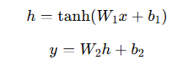
Where:
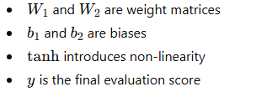
This matches the manual implementation in my program, which uses NumPy for matrix multiplication and does not rely on machine learning frameworks such as TensorFlow or PyTorch. This direct implementation demonstrates an understanding of neural network operations at a low level.

Genetic Algorithms
A genetic algorithm (GA) is an optimisation technique inspired by natural selection. Unlike gradient descent, which requires differentiable loss functions and labelled data, GAs evolve neural network weights purely based on performance.

1 Key Concepts
- Population: A collection of neural networks
- Genome: A vector containing all weights and biases
- Fitness: Performance score (e.g., lines cleared or total score)
- Selection: Higher-fitness networks are more likely to breed
- Crossover: Offspring receive mixed weights from two parents
- Mutation: Small random changes maintain diversity

2 Why GA for Tetris?
Tetris presents several challenges for standard learning methods:
- No clear “correct answer” for each state
- Tetris rewards are delayed and stochastic.
- The search space is large and highly non-linear.
Genetic algorithms avoid these issues by repeatedly:
- Test many versions of the neural network
- Keep the good ones
- Slightly modify them
- Repeat
This evolutionary approach is particularly suitable because the Tetris scoring function is non-differentiable and highly discontinuous. Small changes in behaviour can lead to large changes in outcome, making gradient-based optimisation unreliable. By contrast, genetic algorithms only require a fitness score and are robust to noisy or chaotic environments, making them well suited to this problem domain.
Through generations, high-performing networks emerge.

Neuroevolution: Combining Neural Networks with Genetic Algorithms
This project uses neuroevolution, specifically evolving the neural network’s weight vector using a genetic algorithm. This method has been used in research to play games such as Tetris, Mario, and Flappy Bird.
In my implementation:
- Each genome directly encodes every weight and bias in the neural network.
- During evaluation, the genome constructs a neural network (NeuralNet class).
- That network plays a simulated game via NeuralNetAgent.
- Fitness depends on score and lines cleared.
- Selection uses a tournament-style mechanism.
- Mutation applies Gaussian noise to keep exploration alive.
- Crossover mixes two parents’ weight vectors to form offspring.
This design ensures full transparency and ownership of the learning process. All neural network operations, including forward propagation and weight decoding, are implemented manually using NumPy rather than external machine learning libraries. This allows the system’s behaviour to be fully inspected, tested, and explained, which is particularly important in an educational context such as an NEA.

Search for Actions: Move Simulation
For the AI to decide on a move, the program:
- Generates all legal moves (rotation × horizontal position).
- Clones the current Tetris state.
- Simulates dropping the piece for each move.
- Extracts board features.
- Feeds them through the neural network.
- Picks the move with the highest predicted score.
This technique, known as state evaluation or lookahead simulation, mirrors methods used in chess engines and other decision-based AI systems. Unlike deep search-based systems, this AI evaluates only one move ahead. However, because the evaluation function captures long-term board quality (such as hole creation and surface smoothness), the AI implicitly plans ahead without explicitly searching future moves. This results in efficient decision-making while maintaining strong performance.
This method closely mirrors search processes used in chess engines and other decision-making AI agents.

Comparison With Existing Research
Many Tetris AI projects follow similar strategies, including:
- Genetic optimisation of heuristic weights
- Evolutionary algorithms for board evaluation
- Reinforcement-learning approaches (e.g., DQN)
- Hill-climbing for linear heuristics
My contribution differs by evolving a neural network rather than a linear heuristic, offering more expressive modelling capability and allowing the agent to discover complex relationships between features.
This project differs by evolving a non-linear neural network, granting greater expressive capacity and the ability to discover complex interactions among board features.

Summary of Research Findings
The literature and technical background point to several key conclusions:
- Tetris is highly suited to heuristic-driven or learned evaluation due to its complexity.
Neural networks can capture non-linear relationships between board structure and outcomes.
- Genetic algorithms provide an effective optimisation method in environments lacking labelled data.
- Combining both creates a robust and practical AI architecture.
Analysis and System Design Overview
The developed Tetris game will include:
- Multiplayer Mode: Local competitive play using garbage-line mechanics
- CPU Mode: Play against an AI, with potential adaptive difficulty

Core Challenges
- Synchronising states between multiplayer clients
- Designing an AI that feels human-like and fair

Key Research Questions

AI Algorithm
Problem:
Create a competent, fair AI opponent without giving it unrealistic advantages.
Potential Approaches & Findings:
Approach | Pros | Cons
Heuristic algorithms | Extremely fast; produces human-like decisions | Limited long-term planning
Genetic Algorithms (Bohm et al., 2015) | Learns adaptive playstyle behaviours | Slower to train initially
Reinforcement Learning (e.g., DQN) | Learns long-term survival strategies | Requires GPU and huge training datasets

Q | A
What function evaluates a genetic algorithm solution? | The fitness function evaluates how good each solution (chromosome) is at solving the problem.
Why are non-linear functions used in neural networks? | Non-linear activation functions let neural networks model complex, non-linear relationships; without them, the whole network would just be a linear function.
How do nodes assign input significance? | Nodes assign significance through weights: important inputs get higher weights, and training adjusts these weights to reduce error and improve performance.
What is the main function of a node's activation function? | The activation function decides whether and how strongly a neuron “fires”, adds non-linearity, and enables the network to make decisions such as classifications.
When is a neural network preferred over a genetic algorithm? | Neural networks are preferred for classification, regression, and pattern recognition on continuous or high-dimensional data, especially when learning mappings from inputs to outputs.
Explain the concept of neuroevolution. | Neuroevolution uses evolutionary algorithms (like GAs) to evolve neural networks’ weights and/or architectures over generations based on a fitness measure.
How does each parent differ, what is the process into creating a new generation? | Parents differ in fitness and genes (weights). A new generation is created by selecting fitter parents, copying some as elites, combining others via crossover, and adding random mutations.
List outcomes classification problems typically involve. | Classification outputs are discrete labels or probabilities, e.g. spam/not_spam, cat/dog, fraud/not_fraud, often expressed as 0/1 or class probabilities.
Please explain all the math behind a GNN, why it uses that function and how it benefits compared to others. | A GNN updates each node by aggregating neighbours’ features and applying a learned linear transform plus non-linear activation; this lets it learn from graph structure, making it better than standard NNs for graph data.
Outline the steps required for a genetic algorithm. | Define the problem and fitness function → encode solutions → create initial population → evaluate fitness → select parents → create elites, crossover children, and mutation children → form new population → repeat until a stopping condition is met.

Game Mechanics

Garbage Lines
- Following Tetris Guideline standards, a 4-line clear (“Tetris”) sends 4 garbage lines to the opponent.

Scoring System (Classic Nintendo Model)
- Single: 100 × level
- Tetris: 800 × level
- T-Spin Mini: 200 × level

Pausing & State Integrity
- Use state freezing, where the game loop halts when the pause flag is active.
- Store game state in RAM for instant resume.

Why Use a Neural Network as the Evaluation Function?
The neural network represents a mathematical function:
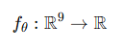
mapping the board features → a single evaluation score
for each possible future move.
Tetris requires evaluating hypothetical outcomes very quickly (30–50 per piece).
A neural network provides:
- Fast computation — O(200) operations per move
- Smooth generalisation — similar boards get similar scores
- Nonlinear modelling — linear heuristics fail for complex situations

Practicality
Your NN runs thousands of forward passes per second, even on older hardware.
It makes real-time AI control feasible.

Why the Network Architecture is 9 → 20 → 1?

9 inputs
These correspond to the board's structural features (heights, holes, wells).
These are chosen because:
- Research shows these features strongly correlate with Tetris success
- They reduce a 200-cell board to a compact 9D signal
- This allows the genome (parameter vector) to stay small (221 numbers)

20 hidden neurons
- Enough capacity to model nonlinear relationships
- Small enough to evolve efficiently

1 output
The AI needs to answer only one question:
“How good is this board state?”

Activation Function: Why Use tanh?
Hidden layer uses:
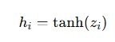

Why tanh was chosen
- Outputs range between -1 and 1, stabilising evaluation
- Zero-centred → avoids bias in evolutionary search
- Smooth nonlinear mapping → crucial for modelling Tetris risk

Practical advantage
If the network output was unbounded (e.g., linear),
genetic mutations would produce wild swings in evaluation,
making training unstable.

Board Feature Mathematics AND WHY EACH ONE MATTERS
It sees engineered mathematical signals designed for efficiency.

1- Aggregate Height
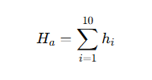
High stacks = higher likelihood of top-out.
Aggregate height is a simple but effective danger indicator.

Practical relevance
Genetic evolution naturally learns to:
- penalise high stacks
- reward flatter boards

2- Maximum Height
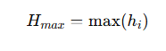

Why is this important
Tetris ends the moment any column reaches the top.
The AI must recognise immediate catastrophic danger.

Practical application
Networks often evolve a strong negative weight for this feature.

3- Holes Calculation
A hole is defined where:
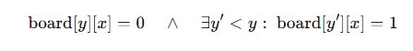

Why this mathematical definition?
This captures EXACTLY the type of pattern that ruins boards:
a buried gap under blocks.

Practical effect
Networks evolve to avoid moves that create or deepen holes.

4- Bumpiness
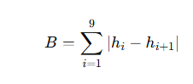
Absolute differences between column heights measure surface roughness.

Why roughness matters
Uneven surfaces:
- reduce survivability
- make holes more likely
- restrict placement of long pieces

5- Height Standard Deviation
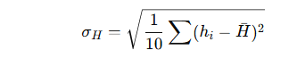

Why variance?
It detects board volatility better than bumpiness alone.
Variance captures global shape patterns that heuristics otherwise miss.

6- Wells
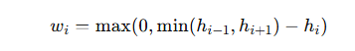

Why this definition?
It captures the depth of vertical cavities.
Deep wells are strategically beneficial because:
- They allow Tetris clears (4-line clears)
- But too deep = dangerous unless used intentionally

Practical behaviour
Networks often evolve:
- mild positive weight for shallow wells
- negative weight for extremely deep ones

Genetic Algorithm
Why These Operators Were Used
The neural network cannot be trained using gradient descent because:
- The score function is non-differentiable
- Tetris outcomes are discrete, chaotic, and path-dependent
- The fitness landscape is rugged with many cliffs and plateaus
Therefore, evolution is mathematically appropriate.

1- Fitness Function Justification


Why does weight line more heavily than score?
Score varies depending on how the pieces land.
Lines cleared is a much more stable proxy for skill.

Practicality
During tests, weighting scores higher made evolution exploit scoring quirks,
but not actual good play.
This weighting solves that.

2- Tournament Selection
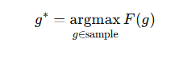

Why tournament selection?
Mathematically:
- Reduces selection pressure if the sample size is small
- Avoids premature convergence
- Doesn’t require sorting the whole population
Practical benefit:
It works extremely well for noisy fitness landscapes like Tetris.

3- Single-Point Crossover
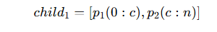

Why this crossover?
Simple, fast, and works well with real-valued genomes.
Practical effect:
Children inherit partial strategies from parents.

4- Gaussian Mutation
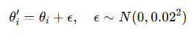

Why Gaussian noise?
Gaussian noise:
- is continuous
- encourages small exploratory steps
- avoids catastrophic jumps from uniform mutation
Practical advantage:
The population stabilises around increasingly good regions,
much like hill-climbing but with genetic diversity.

Why Cloning and Simulation Are Necessary
Before the AI commits to a move, it simulates all possibilities:
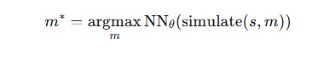

Why simulate?
Tetris moves cannot be safely evaluated without:
- Rotating the piece
- Shifting horizontally
- Hard-dropping
- Locking
- Clearing lines
This is NOT analytically solvable.
It must be evaluated experimentally for each candidate move.

Practical effect
This gives the AI a lookahead, similar to chess engines.

Why Hard Drop Is Modelled Mathematically
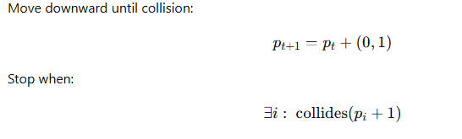

Why this works
Mathematically simple:
- only vector addition and collision checks.
Practicallity:
- Guarantees legal placement
- Works for simulation and gameplay
- Matches human fast-drop behaviour
Mathematical Justification of the Entire System
The combined system is:
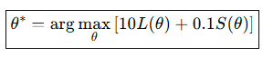

Why this optimisation problem makes sense
- The neural network is a universal approximator
- The GA finds good parameter regions without derivatives
- The features encode all critical board structure
- Simulation ensures the move evaluation is correct
The project is a Python / Pygame application that combines:
- A Tetris game engine (playable by a human player)
- An AI system (Genetic Neural Network) that can autonomously play Tetris
The design is modular and object-oriented:
- Each module has a single responsibility
- Game logic is clearly separated from rendering and from AI
- AI runs on top of the existing Tetris engine rather than being “hard-wired” into it.

1.1 Top-Level Module Structure
Main files:
- MAINTETRIS.py – Main menu and game launcher (human + AI modes)
- main.py – Core game loop (App class)
- TetrisGame.py – Game engine (board, rules, scoring, AI helper methods)
- Tetromino.py – Tetromino and Block classes
- ai_tetris.py – NeuralNet, NeuralNetAgent, GeneticAlgorithm, feature extraction
- ai_autoplay.py / AI mode – Runs Tetris with AI only
- settings.py – Global constants (sizes, colours, timings, shapes)
- button.py – Reusable button UI component
- train_ga.py – Offline training script for evolving neural network weights

1.2 High-Level Architecture
MAINTETRIS.py (main menu)
├── App (from main.py) – standard Tetris game loop (human)
├── App(ai_mode=True) – AI-driven game loop
└── Menu / Buttons – navigation
TetrisGame.py
├── Tetris – board, rules, scoring, simulation
└── Text – on-screen labels (NEXT, SCORE, TETRIS)
Tetromino.py
├── Tetromino – current piece
└── Block – individual squares (sprites)
ai_tetris.py
├── NeuralNet – feed-forward NN (9→20→1)
├── NeuralNetAgent – move selection via simulation
└── GeneticAlgorithm – evolve NN weights
settings.py
└── Constants – field size, tile size, colours, timing, tetromino shapes

1.3 System Architecture Diagram
+--------------------+ +-------------------------+
| Pygame Window | | Genetic Algorithm |
| (Rendering/UI) | | fitness evaluation |
+---------+----------+ +-----------+-------------+
| |
v v
+--------------------+ +------------------------+
| Tetris | <-----> | Neural Network |
| (Game state, | NN | (score evaluator for |
| piece movement, | scores | simulated boards) |
| collisions, lines) | states +-----------+------------+
+---------+----------+ |
| |
v v
+--------------------+ +------------------------+
| Tetromino / Block | | NeuralNetAgent |
| (piece logic, | | (simulates all moves |
| rotation, falling) | | and selects best) |
+--------------------+ +------------------------+

2. System Decomposition & Structure

2.1 Stepwise Refinement
The single significant problem (“make a Tetris AI game”) is refined into sub-problems:
- Display Control
  - Set up Pygame window (App / AIApp)
  - Draw grid, pieces, text, and UI elements.
- Game Logic (Tetris Engine)
  - Manage field_array (board)
  - Handle piece spawning, movement, and collision.
  - Clear complete lines and update the score
- Input Handling
  - Keyboard input for human play (arrow keys, ESC)
  - Pygame events for quitting
- AI Move Selection (AI System)
  - Extract board features
  - Simulate all legal moves.
  - Use NN to evaluate each simulated result.
  - Execute the move with the highest score.
- Neural Network & Genetic Algorithm
  - Neural net representation (weights & biases)
  - Fitness evaluation via simulated games
  - GA operators: selection, crossover, mutation
- Menu System / Navigation
  - Main menu (Play, AI Play, Options, Quit)
  - Button hover & click detection.
  - Launch App or App(ai_mode=True)
- Settings & Assets
  - Centralised constants in settings.py
  - Paths for sprites, fonts, and background image

2.2 Structure / Hierarchy Chart
App / AIApp (main loop)
│
├── Tetris (engine)
│ ├── Tetromino (current piece)
│ │ └── Block (sprites)
│ ├── Collision detection
│ ├── Line clearing
│ ├── Scoring / lines_cleared
│ └── AI helper methods
│ ├── clone()
│ ├── get_board_matrix()
│ ├── get_possible_moves()
│ └── apply_ai_move()
│
├── Text (UI labels)
└── Menu / Buttons (in MAINTETRIS.py)
└── Button (from button.py)

AI Subsystem (ai_tetris.py)
│
├── NeuralNet
├── NeuralNetAgent
└── GeneticAlgorithm

3. Object-Oriented Design

3.1 Class Identification
Class | Responsibility
App / AIApp | Window, main loop, timers, screens, link to Tetris
Tetris | Board state, scoring, line clearing, tetromino management
Tetromino | Shape, rotation, and movement of the current tetromino
Block | Individual square; sprite drawing & collision checking
Text | Rendering labels like “TETRIS”, “NEXT”, and score
Button | Menu buttons (hover, click, label drawing)
NeuralNet | Feed-forward network evaluating board features
NeuralNetAgent | Uses NeuralNet to pick the best move via simulation
GeneticAlgorithm | Evolves genomes (neural net weights)

3.1 Tetris Engine Classes

Class: Tetris
Responsibilities:
- Maintain the board (field_array)
- Track score, lines cleared, and game-over state
- Update tetromino positions (gravity, locking, spawning)
- Clear completed lines
- Provide simulation tools for the AI, such as:
  - clone()
  - get_board_matrix()
  - get_possible_moves()
  - apply_ai_move(move)
Key design decision:
The class supports a simulation mode (is_simulation=True).
This prevents cloned game states from rendering or polluting the sprite group.
This was essential to fix an earlier bug, “rainbow explosion,” caused by simulation blocks appearing on screen.
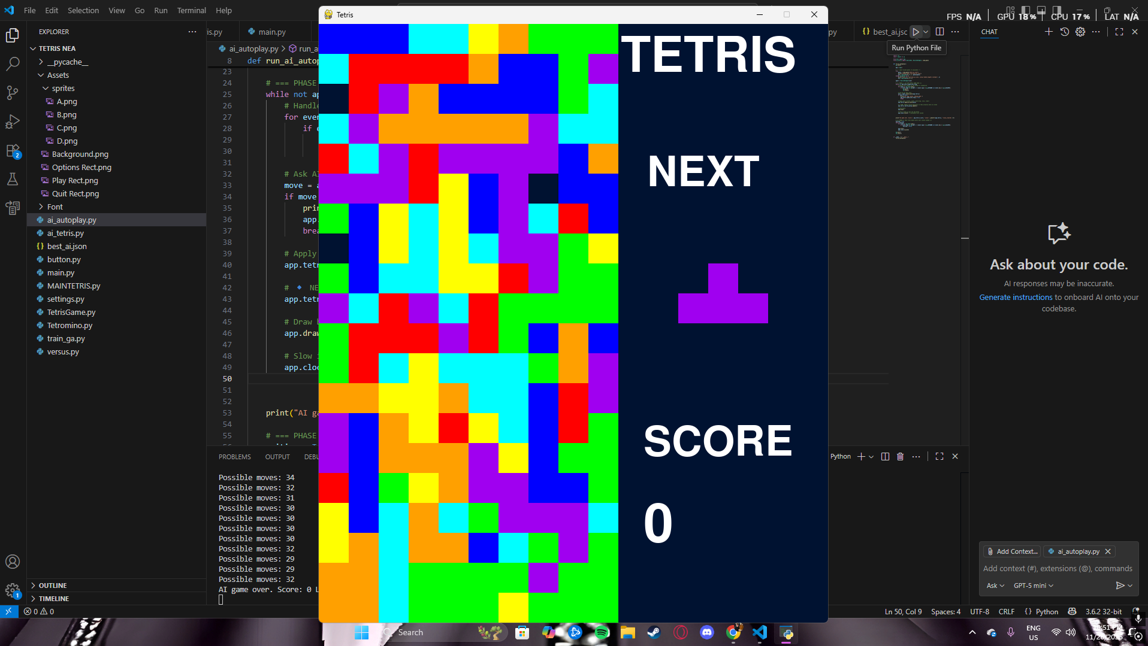

Class: Tetromino
Responsibilities:
- Store shape, rotation, and four block positions
- Rotate the piece around a pivot.
- Move left/right/down.
- Detect collisions before applying moves.
Key design decision:
Blocks depend on the Tetromino instance but are rendered separately.

Class: Block
Responsibilities:
- Store tile position
- Update sprite location on-screen.
- Detect collisions individually
Key design decision:
Blocks are only pg.sprite.Sprite instances when NOT in simulation.
This avoids unintended rendering of simulated piece movements.

3.2 UML-Style Class Overview (Text)
App / AIApp
- Attributes: screen, clock, images, tetris, text, timers, ai_agent (AI mode only)
- Methods: run(), update(), draw(), check_events(), ai_control() (AI mode)
Tetris
- Attributes:
field_array, tetromino, next_tetromino, sprite_group,
score, lines_cleared, full_lines, game_over_flag, is_simulation, offset_tiles
- Methods:
update(), draw(), control(), check_full_line(),
put_tetromino_blocks_in_array(), get_field_array(),
game_over(), mark_game_over_if_needed(),
get_board_matrix(), clone(),
get_possible_moves(), apply_ai_move(move)
Tetromino
- Attributes: shape, blocks, image, landing, current_shape, tetris
- Methods: rotate(), move(direction), has_collided(positions), update()
- Property: pos (pivot block position)
Block
- Attributes: pos, next_pos, alive, image, rect, tetromino
- Methods: rotate(pivot_pos), update(), set_rect_pos(), has_collided(pos), is_alive()
Text
- Attributes: app, font
- Methods: draw()
Button
- Attributes: image, x_pos, y_pos, font, text, rect, text_rect
- Methods: update(screen), checkForInput(position), changeColor(position)
NeuralNet
- Attributes: n_inputs, n_hidden, n_outputs, genes, W1, b1, W2, b2
- Methods: decode_genes(), forward(x), evaluate(features)
NeuralNetAgent
- Attributes: nn
- Methods: choose_move(game)
GeneticAlgorithm
- Attributes: population, genome_length, population_size, best_genes, best_fitness, etc.
- Methods:
_run_game_with_agent(), evaluate_fitness(genes),
tournament_selection(), crossover(), mutate(), evolve_one_generation(),
get_best_network()

3.3 Relationships
- App/AIApp → Tetris: Composition (App owns a Tetris board instance).
- Tetris → Tetromino: Composition (game cannot function without a tetromino).
- Tetromino → Block: Composition (blocks cannot exist independently).
- App → Text: Composition (Text draws to App’s screen).
- MAINTETRIS.py → Button: Aggregation (buttons exist for the menu).
- AIApp / App(ai_mode=True) → NeuralNetAgent: Association.
- NeuralNetAgent → Tetris: Uses Tetris interface methods for simulation only.
- GeneticAlgorithm → NeuralNet / NeuralNetAgent: Constructs them for fitness evaluation.
There is no need for an inheritance hierarchy: responsibilities are clearly separated, and composition is preferred.

3.4 Encapsulation
- Each class controls its own internal data.
- Game state (field_array, score, lines_cleared) is not modified directly from outside; instead, methods like update(), control(), apply_ai_move() are used.
- Constants (e.g. FIELD_W, TILE_SIZE, TETROMINOES) are read from settings.py to avoid magic numbers and improve maintainability.

4. Data Structures and Storage

4.1 Key Data Items
- Board state: 2D list (field_array) of blocks or 0.
- Tetromino shapes: Dictionary TETROMINOES mapping shape names to coordinate patterns.
- Blocks: Instances of Block, optionally stored in sprite_group for rendering.
- Score and lines: Integers (score, lines_cleared, full_lines).
- Neural network weights: Numpy arrays (genes, W1, W2, b1, b2).
- Genetic algorithm population: List of numpy arrays.
- Best model: Stored in best_ai.json as a flat list of floats.

4.2 Internal Data Structures (RAM)
Data | Structure | Reason
Grid | 2D list (list of lists) | Easy index access with grid[y][x], simple to iterate over rows
Tetromino shapes | Dict {char: list} | Fast lookup of positions by shape type
Blocks | Pygame sprite group | Efficient batched drawing and updating
Features | NumPy array | Efficient vector maths for NN input
Genome population | List of NumPy arrays | Simple GA operations (mutate, crossover, copy)

4.3 Persistent Storage
- No database is used; all gameplay is in-memory.
- The only file-based data used during AI training is:
  - best_ai.json – JSON flat array of best-performing genome (NN weights).
File format justification:
- JSON is human-readable, easy to edit if needed, and has native support in Python.
- The genome is purely numeric and can be deserialised straight back into a NumPy array.

4.2 Neural Network Design

Architecture
Input Layer (9 features)
↓
Hidden Layer (20 neurons, tanh activation)
↓
Output Layer (1 score)

Parameters:
- 9 inputs → derived from board features
- 20 hidden neurons → expressive enough for patterns
- 1 output neuron → single score representing board quality
Justification:
- A single scalar score simplifies AI decision-making
- The architecture is small enough to evaluate quickly for GA fitness
- Manual implementation demonstrates understanding of neural network mathematics
The neural network does not choose actions directly, but assigns scores to simulated final board states.

4.3 Move Simulation and Selection
The AI evaluates moves using this algorithm:
for each rotation (0–3):
rotate the piece on a clone
for each x-position (-3 to FIELD_W+3):
simulate horizontal shift
simulate gravity drop
evaluate resulting board with neural network
choose move with highest score

Design benefits:
- The agent never performs illegal moves
- Full move simulation means the NN only predicts the final board outcome.
- Guarantees deterministic behaviour: same board → same decision
4.4 Genetic Algorithm Design

Genome Representation

A genome is a flat array of weights and biases:
[W1..., b1..., W2..., b2...]

The total length =
n_inputs*n_hidden + n_hidden + n_hidden*n_outputs + n_outputs

GA Cycle
- Initialise random population
- For each genome:
  - Construct NN
  - Play a simulated Tetris game.
  - Score fitness (lines cleared + weighted score)
- Selection (tournament)
- Crossover (single-point)
- Mutation (Gaussian noise)
- Repeat for N generations.
- Save the best genome to best_ai.json

Justification:
- GA does not require differentiable functions
- Works well for sparse/delayed rewards like Tetris
- Allows student-level understanding and full code ownership

5. Algorithms and Processing

5.1 Core Tetris Algorithms
1. Collision Detection
Ensures pieces do not overlap existing blocks or go out of bounds.
FUNCTION has_collided(block, pos):
x ← int(pos.x)
y ← int(pos.y)
IF x < 0 OR x ≥ FIELD_W:
RETURN True
IF y ≥ FIELD_H:
RETURN True
IF y ≥ 0 AND field_array[y][x] IS NOT empty:
RETURN True
RETURN False
2. Line Clearing
FUNCTION check_full_line():
row ← FIELD_H - 1
FOR y FROM FIELD_H - 1 DOWNTO 0:
FOR x FROM 0 TO FIELD_W - 1:
cell ← field_array[y][x]
field_array[row][x] ← cell
IF cell IS Block:
cell.pos ← (x, row)

IF number of non-empty cells in row y < FIELD_W:
row ← row - 1
ELSE:
FOR x FROM 0 TO FIELD_W - 1:
cell ← field_array[row][x]
IF cell IS Block:
cell.alive ← False
field_array[row][x] ← 0
full_lines ← full_lines + 1
3. Tetromino Movement & Gravity
FUNCTION update():
IF animation_trigger OR (speed_up AND fast_animation_trigger):
check_full_line()
tetromino.update() # moves piece down
check_tetromino_landing()
get_score()
IF NOT is_simulation:
sprite_group.update()
4. Scoring
FUNCTION get_score():
score ← score + points_per_line[full_lines]
lines_cleared ← lines_cleared + full_lines
full_lines ← 0

5.2 AI Algorithms
1. Feature Extraction
Converts board matrix to 9-element feature vector (aggregate height, holes, bumpiness, etc.). (Detailed in the Research section.)
2. Move Simulation (NeuralNetAgent)
FUNCTION choose_move(game):
possible_moves ← game.get_possible_moves()
IF possible_moves IS empty:
RETURN None

best_move ← None
best_score ← -∞

FOR move IN possible_moves:
sim ← game.clone()
sim.apply_ai_move(move)
board ← sim.get_board_matrix()
features ← extract_features(board)
score ← nn.evaluate(features)
IF score > best_score:
best_score ← score
best_move ← move

RETURN best_move

3. Genetic Algorithm Loop (train_ga.py)
FUNCTION train():
ga ← GeneticAlgorithm(...)

FOR generation FROM 1 TO N:
best_fit ← ga.evolve_one_generation()
PRINT "Generation", generation, "– Best fitness", best_fit

save_genes("best_ai.json", ga.best_genes)

These algorithms together satisfy the processing requirements: valid Tetris behaviour, AI decision-making, and evolvable neural networks.

6. User Interface (UI) Design

6.1 Main Screens
Main Menu (MAINTETRIS.py)
- Background image (Assets/Background.png)
- Buttons: PLAY, AI PLAY, OPTIONS, QUIT
- Hover effect: text colour change
Navigation:
  - PLAY → human Tetris (App(ai_mode=False))
  - AI PLAY → AI Tetris (App(ai_mode=True))
OPTIONS → placeholder screen
  - QUIT → exit program
Game Window (Tetris)
- Left: Tetris grid
- Right: “TETRIS”, “NEXT”, “SCORE”, numeric score
- AI mode: “AI MODE” or “AI PLAYING” label drawn at bottom right
- ESC key: returns to the menu or quits

6.2 UI Interaction Table
Element | Interaction | Behaviour
PLAY button | Left click | Starts human-controlled Tetris
AI PLAY | Left click | Starts AI-controlled Tetris
OPTIONS | Left click | Opens options screen (placeholder)
QUIT | Left click | Quits application
ESC (in-game) | Key press | Quit or return to the menu
Arrow keys | Key press | Move/rotate tetromino (human mode)

6.3 Navigation Flow
[Main Menu]
├── PLAY → [Game Window - Human]
├── AI PLAY → [Game Window - AI]
├── OPTIONS → [Options Screen] → Back → [Main Menu]
└── QUIT → Exit

7. AI Integration & Runtime Design

7.1 AI Mode (AIApp / App(ai_mode=True))
- Uses the same Tetris class and rendering pipeline.
- Instead of reading keyboard input, calls ai_control() every frame:
FUNCTION ai_control():
ai_move_timer += 1
IF ai_move_timer ≥ ai_move_delay AND NOT move_executed:
move ← ai_agent.choose_move(tetris)
IF move IS NOT None:
execute_ai_move(move)
move_executed ← True

IF new tetromino has just spawned:
move_executed ← False

execute_ai_move(move):
  - Apply rotations
  - Move horizontally to target_x
  - Enable fast drop (speed_up = True)

7.2 Separation of Concerns
- The Tetris engine is agnostic to whether moves come from a human or an AI.
- The AI only uses public methods (clone(), apply_ai_move(), etc.) and does not directly manipulate internal data structures.

8. Success Criteria (Design-Level)
The design has been created to meet these measurable goals:
- The AI can play a full game of Tetris autonomously.
- The AI only makes legal moves using the same rules as the human player.
- Feature extraction works correctly and consistently for all board states.
- The trained AI (from best_ai.json) achieves higher average scores and lines than a random or naïve agent.
- The UI clearly shows the game state, next piece, and score in both human and AI modes.
- Simulation mode (is_simulation=True) ensures AI evaluation does not corrupt or visually break the main game board.
Design Aspect | Addressed? | Where in Design
System decomposition / top level | Yes | Sections 1–2, hierarchy chart
Stepwise refinement | Yes | Section 2.1
OOP classes and relationships | Yes | Section 3
Class diagram (text UML) | Yes | Section 3.2
Encapsulation & composition | Yes | Section 3.3–3.4
Data structures & justification | Yes | Section 4
Database/storage choice | Yes | Section 4.3 (no DB, JSON for AI)
Algorithms & pseudocode | Yes | Section 5
Algorithm purpose & explanation | Yes | Sections 5.1–5.2
User Interface design & navigation | Yes | Section 6
AI / GNN design and integration | Yes | Sections 5.2, 7

1.1 Main Game Loop

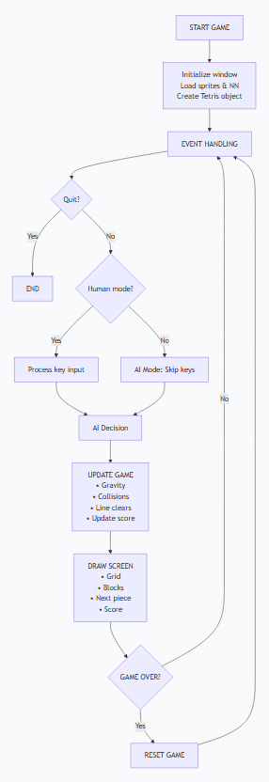

1.2 AI Move Calculation
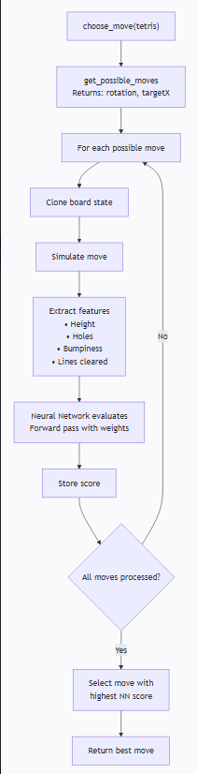

1.3 Genetic Algorithm Training
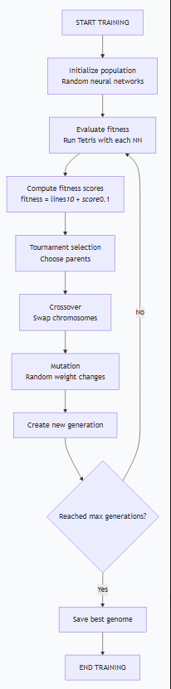

2. PROGRAM ARCHITECTURE DIAGRAM
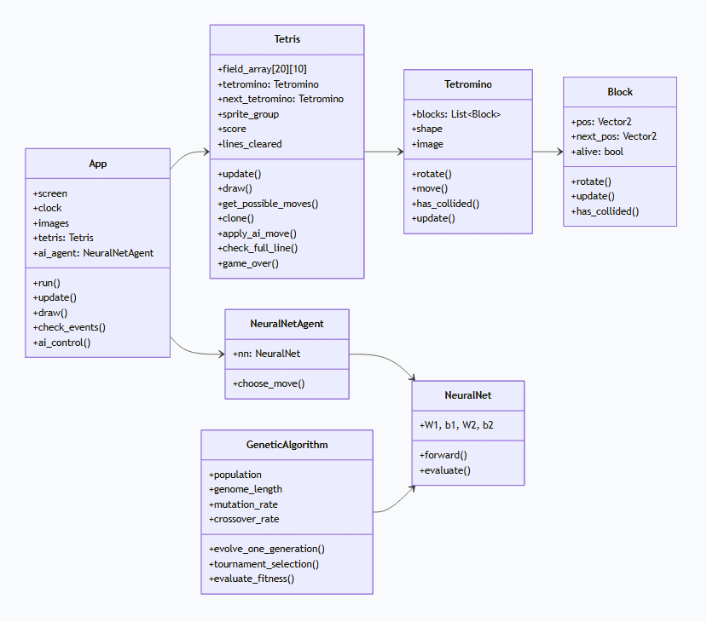

3. DATA FLOW DIAGRAM
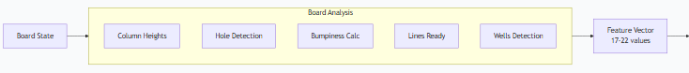
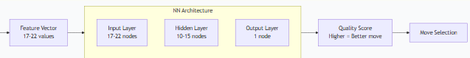

4. TESTING WORKFLOW
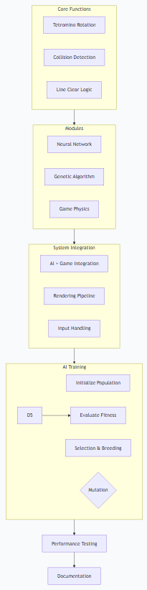

5. TIMELINE VISUALIZATION

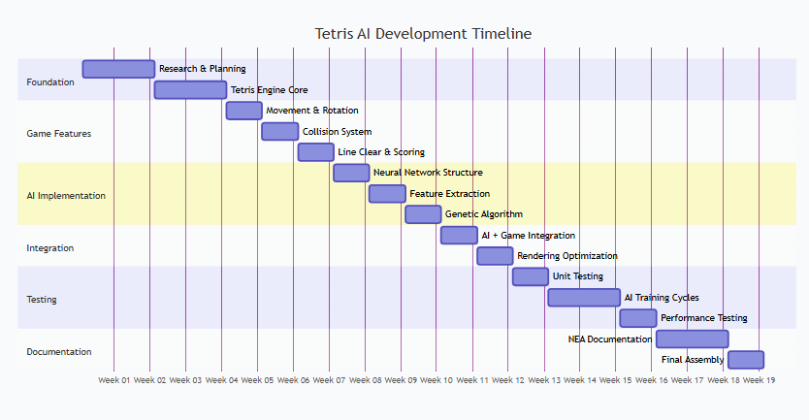

6. NEURAL NETWORK ARCHITECTURE
